7.45: a)
b) The second height is 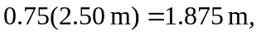 so second 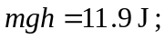 loses 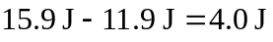 on first bounce. This energy is converted to thermal energy.
- The third height is 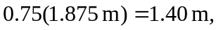, so third 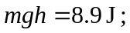 loses 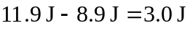 on second bounce.

